UK COMMERCIAL VEHICLE MANUFACTURING

28 April 2016 (data for March and Q1 2016)

Commercial vehicle output steady in first quarter following 2015 boom
- Q1 figures show 0.9% growth with 23,639 CVs made in Britain so far in 2016.
- Commercial vehicle production falls -13.0% in March.
- Exports drive demand, up 19.8% in Q1 with more than half of UK-built CVs sold overseas.
28 April, 2016 UK commercial vehicle manufacturing saw a decline in March 2016, according to new figures from the Society of Motor Manufacturers and Traders (SMMT). 8,398 CVs were built in Britain last month, down -13.0% compared with the previous year as the market rebalanced following a particularly strong performance in March 2015.

First quarter production volumes remained stable, rising 0.9% on 2015 and marking the strongest quarter in more than four years. The growth was driven by overseas demand, up almost a fifth compared with the same period last year, with 12,450 vehicles exported.

Mike Hawes, SMMT Chief Executive, said, “Following the substantial boost to volumes seen in 2015, it is unsurprising that March’s production figures were more subdued. However, exports are driving output, with more than half of all the commercial vehicles made in Britain in 2016 produced for overseas buyers. With continued recovery in Europe, we can be optimistic that this trend will continue.”
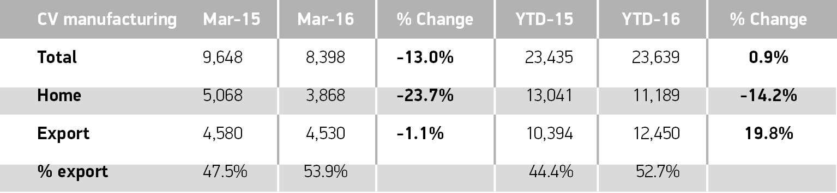
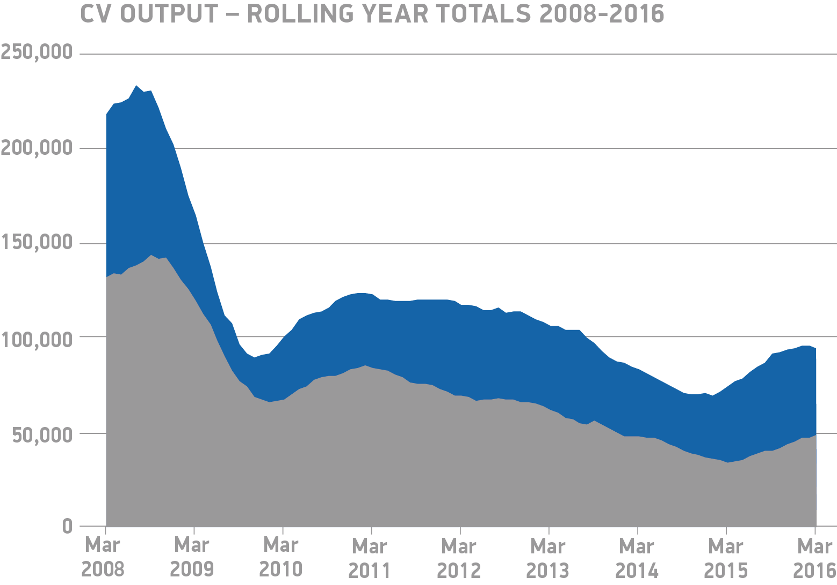
Notes to editors

About SMMT and the UK automotive industry

The Society of Motor Manufacturers and Traders (SMMT) is one of the largest and most influential trade associations in the UK. It supports the interests of the UK automotive industry at home and abroad, promoting a united position to government, stakeholders and the media.

The automotive industry is a vital part of the UK economy accounting for more than £69.5 billion turnover and £15.5 billion value added. With some 160,000 people employed directly in manufacturing and in excess of 799,000 across the wider automotive industry, it accounts for 11.8% of total UK export of goods and invests £2.4 billion each year in automotive R&D. More than 30 manufacturers build in excess of 70 models of vehicle in the UK supported by around 2,500 component providers and some of the world’s most skilled engineers.

More detail on UK automotive available in SMMT’s Motor Industry Facts 2015 publication at www.smmt.co.uk/facts15.

Broadcasters: SMMT has an ISDN studio and access to expert spokespeople, case studies and regional representatives.
Media contacts

Ben Foulds | 020 7344 9222 | bfoulds@smmt.co.uk
Lucy Bielby | 020 7344 1610 | lbielby@smmt.co.uk
Emma Butcher | 020 7344 9263 | ebutcher@smmt.co.uk
Francesca Fleming | 020 7344 9206 | ffleming@smmt.co.uk

