UK COMMERCIAL VEHICLE MANUFACTURING

30 June 2016 (data for May 2016)
UK CV production enjoys double-digit boost in May
- May UK commercial vehicle (CV) output increases 13.8% to 7,748 units.
- Home market drives growth, with demand rising 23.5% compared with the same month in 2014.
- Exports grow 5.7% as European economic recovery continues.
Thursday 30 June, 2016 UK CV manufacturing volumes rose last month, with output growing 13.8% to 7,748 units, according to figures published today by the Society of Motor Manufacturers and Traders (SMMT). The home market drove output, with demand up almost a quarter, while production for export also enjoyed substantial gains, putting the overall sector up by 2.7% in the year to date.

The news comes as European commercial vehicle markets reported a 17th month of growth as the region continued its economic recovery. New commercial vehicle registrations in Europe grew 16.4% in May, with the market up 13.5% for the first five months of 2016¹.

Mike Hawes, SMMT Chief Executive, said, “It’s good to see UK commercial vehicle manufacturing performing strongly in May which puts it on track for a positive 2016. The commercial vehicle market is linked to economic confidence in the UK and Europe, with 88% of UK-built CV exports shipped to the continent last year. For this performance to continue, we need to ensure we maintain free access to our main markets as well as pursuing new global opportunities.”
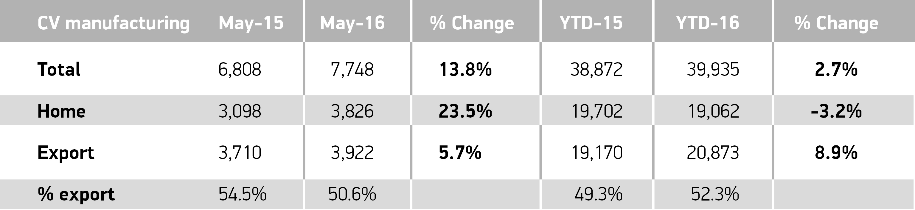
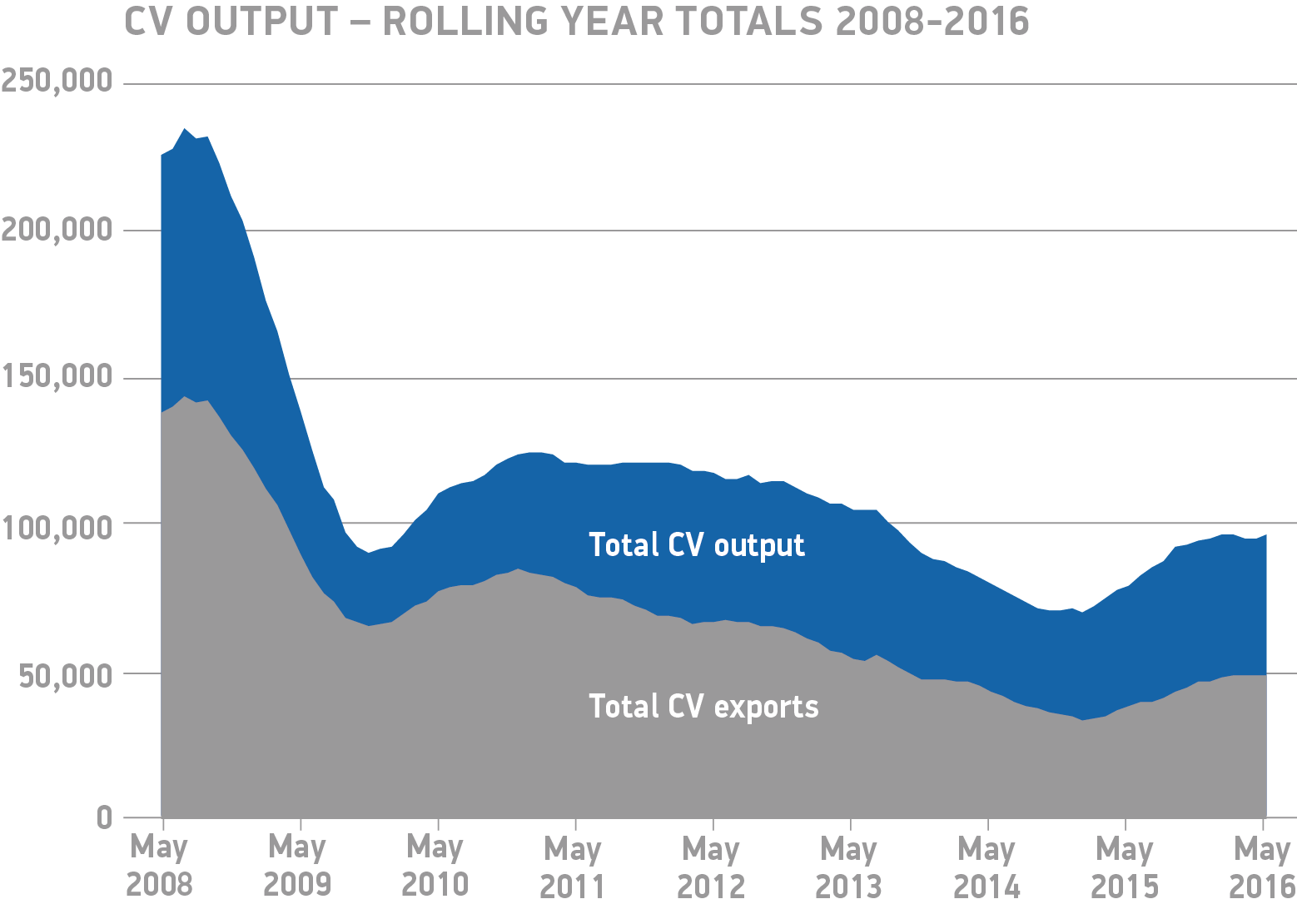
Notes to editors
1. European Automobile Manufacturers Association (ACEA)
Hi-res images available here: https://www.dropbox.com/sh/3ghc59wysza8w8p/AACRUiNht04GgafnMwZoQYoza?dl=0
About SMMT and the UK automotive industry
The Society of Motor Manufacturers and Traders (SMMT) is one of the largest and most influential trade associations in the UK. It supports the interests of the UK automotive industry at home and abroad, promoting a united position to government, stakeholders and the media.
The automotive industry is a vital part of the UK economy accounting for more than £71.6 billion turnover and £18.9 billion value added. With some 169,000 people employed directly in manufacturing and 814,000 across the wider automotive industry, it accounts for12.0% of total UK export of goods and invests £2.5 billion each year in automotive R&D. More than 30 manufacturers build in excess of 70 models of vehicle in the UK supported by more than 2,000 component providers and some of the world's most skilled engineers.
More detail on UK automotive available in SMMT's Motor Industry Facts 2016 publication at www.smmt.co.uk/facts16.
Broadcasters: SMMT has an ISDN studio and access to expert spokespeople, case studies and regional representatives.
Media contacts

Ben Foulds | 020 7344 9222 | bfoulds@smmt.co.uk
Lucy Bielby | 020 7344 1610 | lbielby@smmt.co.uk
Emma Butcher | 020 7344 9263 | ebutcher@smmt.co.uk

