UK CAR MANUFACTURING (data for February 2016)
Hi-res images available here:

https://www.dropbox.com/sh/bhayxavylna2bg2/AADKqhTCTF7CbwTBgCMEXuBGa?dl=0
Double-digit growth for British car manufacturing in February
- UK car production continues strong start to 2016, with 13.1% growth in February.
- Export production increases 9.1%, with output for UK market up by a quarter.
- 284,507 cars built in the year so far, up 10.6% on 2015.
24 March, 2016 British car manufacturing achieved another month of strong growth in February with output up 13.1%, according to figures released today by the Society of Motor Manufacturers and Traders (SMMT).

Reflecting the growing popularity of UK-built cars both at home and abroad, February’s performance puts production for the year-to-date up 10.6% over the same period last year. Output for the domestic market rose 24.4% in the month, accompanied by a robust 9.1% increase in export production.

Mike Hawes, SMMT Chief Executive, said, “The UK automotive industry’s impressive growth continued into February, with demand from both domestic and overseas customers showing no signs of slowing. The outlook for the sector is bright, but much will depend on global political and economic conditions in the months and years to come.”
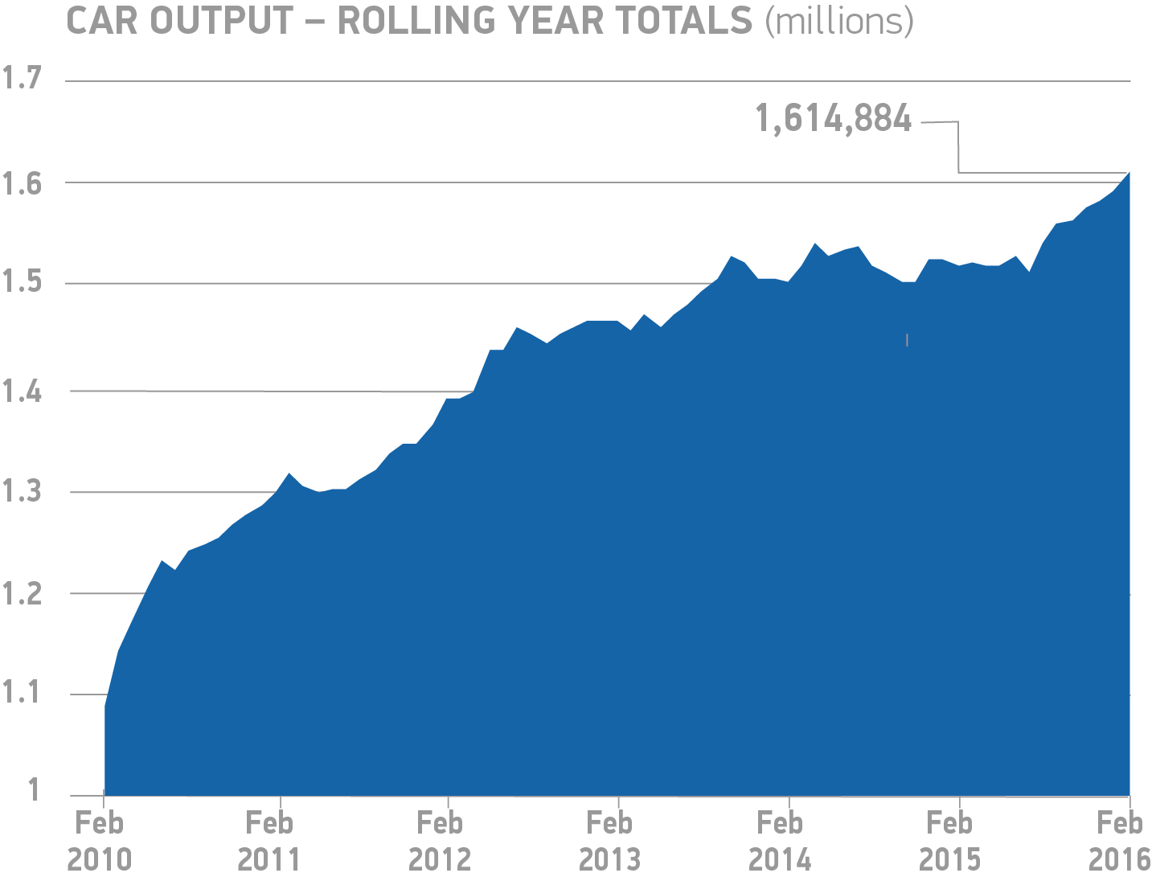
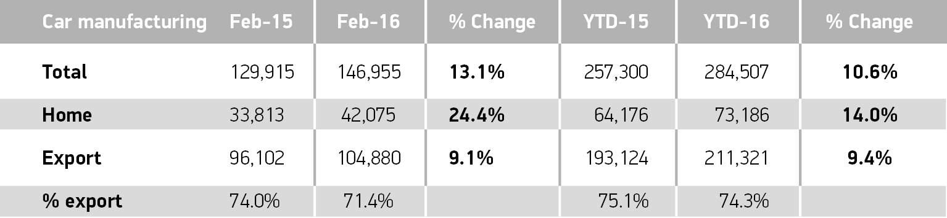
Notes to editors

About SMMT and the UK automotive industry

The Society of Motor Manufacturers and Traders (SMMT) is one of the largest and most influential trade associations in the UK. It supports the interests of the UK automotive industry at home and abroad, promoting a united position to government, stakeholders and the media.

The automotive industry is a vital part of the UK economy accounting for more than £69.5 billion turnover and £15.5 billion value added. With some 160,000 people employed directly in manufacturing and in excess of 799,000 across the wider automotive industry, it accounts for 11.8% of total UK export of goods and invests £2.4 billion each year in automotive R&D. More than 30 manufacturers build in excess of 70 models of vehicle in the UK supported by around 2,500 component providers and some of the world's most skilled engineers.

More detail on UK automotive available in SMMT's Motor Industry Facts 2015 publication at www.smmt.co.uk/facts15.

Broadcasters: SMMT has an ISDN studio and access to expert spokespeople, case studies and regional representatives.
Media contacts
Ben Foulds | 020 7344 9222 | bfoulds@smmt.co.uk
Francesca Fleming  Emma Butcher | 020 7344 9206  020 7344 9263 | ffleming@smmt.co.uk  ebutcher@smmt.co.uk

