UK ENGINE MANUFACTURING

28 April 2016 (data for March and Q1 2016)
Positive first quarter for UK engine production as strong domestic demand drives output
- Positive first quarter, with overall production volumes up 3.5% to 667,888 units.
- UK demand for British-built engines grows 24.6% in March, with 97,326 units produced.
- Total engine output steady in March, down -1.5% on last year.
Mike Hawes, SMMT Chief Executive, said, “Significant growth in domestic demand for British-built engines in March helped the sector achieve a steady performance for the month, down marginally by -1.5%. New UK facilities this year have catered predominantly for the growing home market, with manufacturing for export down -9.3%. However, overseas demand remains strong, with customers in international territories continuing to take the bulk of output, and accounting for 56.7% of overall production.”
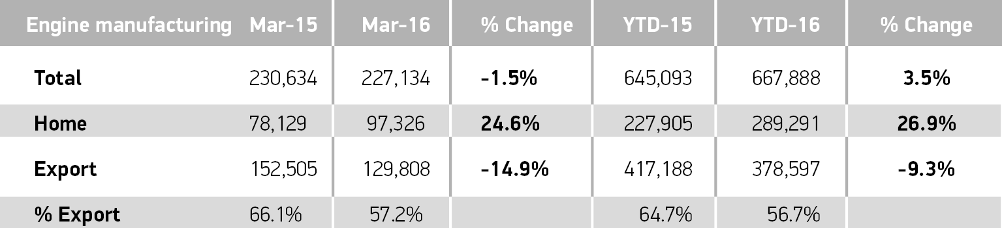

Notes to editors

About SMMT and the UK automotive industry

The Society of Motor Manufacturers and Traders (SMMT) is one of the largest and most influential trade associations in the UK. It supports the interests of the UK automotive industry at home and abroad, promoting a united position to government, stakeholders and the media.

The automotive industry is a vital part of the UK economy accounting for more than £69.5 billion turnover and £15.5 billion value added. With some 160,000 people employed directly in manufacturing and in excess of 799,000 across the wider automotive industry, it accounts for 11.8% of total UK export of goods and invests £2.4 billion each year in automotive R&D. More than 30 manufacturers build in excess of 70 models of vehicle in the UK supported by around 2,500 component providers and some of the world’s most skilled engineers.

More detail on UK automotive available in SMMT’s Motor Industry Facts 2015 publication at www.smmt.co.uk/facts15.

Broadcasters: SMMT has an ISDN studio and access to expert spokespeople, case studies and regional representatives.
Media contacts

Ben Foulds | 020 7344 9222 | bfoulds@smmt.co.uk
Emma Butcher | 020 7344 9263 | ebutcher@smmt.co.uk
Francesca Fleming | 020 7344 9206 | ffleming@smmt.co.uk
Lucy Bielby | 020 7344 1610 | lbielby@smmt.co.uk

