SMMT AUTOMOTIVE MANUFACTURING
19 May 2011 (data for April 2011)

NEWS RELEASE NUMBER | 4904 | FOR RELEASE | IMMEDIATE

SMMT Ltd | Cars |  | Commercial Vehicles |  | Total Vehicles |  | Total Engines
Data: | Apr-11 | YTD-11 | Apr-11 | YTD-11 | Apr-11 | YTD-11 | Apr-11 | YTD-11
Total | 86,306 | 443,536 | 8,633 | 40,790 | 94,939 | 484,326 | 190,131 | 875,362
% change | -12.2% | 7.0% | -19.9% | -5.6% | -13.0% | 5.8% | -4.7% | 6.0%
Export | 73,628 | 370,502 | 5,366 | 25,456 | 78,994 | 395,958 | 151,225 | 636,726
% change | 1.7% | 23.0% | -22.0% | -16.1% | -0.4% | 19.4% | 2.4% | 4.5%
% of total | 85.3% | 83.5% | 62.2% | 62.4% | 83.2% | 81.8% | 79.5% | 72.7%
Home | 12,678 | 73,034 | 3,267 | 15,334 | 15,945 | 88,368 | 38,906 | 238,636
% change | -51.0% | -35.4% | -16.1% | 19.1% | -46.4% | -29.8% | -25.0% | 10.0%
% of total | 14.7% | 16.5% | 37.8% | 37.6% | 16.8% | 18.2% | 20.5% | 27.3%

- Car output was up 7.0% over the first four months of 2011, but fell by 12.2% in April.
- CV output fell by 19.9% in April and was down 5.6% over the first four months of the year.
- UK engine production fell by 4.7% in April, but remained up 6.0% over the first four months.

“April’s vehicle and engine production figures reflect the global production challenges resulting from the Japanese earthquake. Output was down across the car, commercial vehicle and engine sectors as parts shortages interrupted regular manufacturing schedules,” said Paul Everitt, SMMT Chief Executive. “All manufacturers are working hard to overcome supply shortages and we expect any downturn to be short lived. The outlook for the UK motor industry is extremely good and this should generate new opportunities for vehicle manufacturers and suppliers.”

Car production – rolling year total
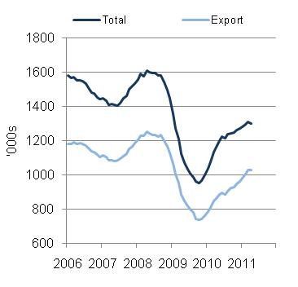

CV production – rolling year total
