SMMT AUTOMOTIVE MANUFACTURING

20 October 2011 (data for September 2011)

NEWS RELEASE NUMBER 4947 FOR RELEASE IMMEDIATE

Strong September sets scene for 2012 manufacturing momentum

- Car manufacturing rose by 7.5% in September and is up 4.8% over the first nine months of 2011.
- CV output rose by 6.2% in September, but was down 2.7% over the January-September period.
- UK engine production rose by 6.6% in September and is up 5.0% over the year-to-date.

“September saw a 7.4% increase in UK vehicle manufacturing, confirming a positive trend we expect to continue into 2012,” said Paul Everitt, SMMT Chief Executive. “Major new investment by vehicle manufacturers is opening up opportunities for UK-based suppliers, helping to drive the economic recovery and private sector investment.”

SMMT Ltd | Cars |  | Commercial Vehicles |  | Total Vehicles |  | Total Engines
Data: | Sep-11 | YTD-11 | Sep-11 | YTD-11 | Sep-11 | YTD-11 | Sep-11 | YTD-11
Total | 136,051 | 983,247 | 12,046 | 89,026 | 148,097 | 1,072,273 | 244,270 | 1,889,376
% change | 7.5% | 4.8% | 6.2% | -2.7% | 7.4% | 4.2% | 6.6% | 5.0%
Export | 112,347 | 811,680 | 6,902 | 51,770 | 119,249 | 863,450 | 166,033 | 1,360,165
% change | 22.0% | 19.3% | -7.4% | -17.4% | 19.8% | 16.2% | 1.8% | 4.5%
% of total | 82.6% | 82.6% | 57.3% | 58.2% | 80.5% | 80.5% | 68.0% | 72.0%
Home | 23,704 | 171,567 | 5,144 | 37,256 | 28,848 | 208,823 | 78,237 | 529,211
% change | -31.3% | -33.4% | 32.4% | 29.0% | -24.8% | -27.1% | 18.3% | 6.3%
% of total | 17.4% | 17.4% | 42.7% | 41.8% | 19.5% | 19.5% | 32.0% | 28.0%

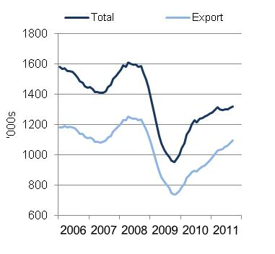
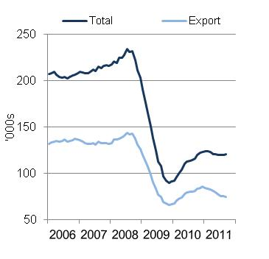
Car production rolling year total CV production rolling year total

Growing the UK automotive supply chain
Industry is committed to boosting the UK automotive supply chain and identifying opportunities to enhance domestic and international demand for UK components. SMMT regularly hosts ‘Meet the Buyer’ events, designed to match OEM sourcing demand to UK suppliers, helping to establish relationships and strengthen the UK supply chain. Forthcoming ‘Meet the Buyer’ events will take place on 31 October, 8 November and 15 November. For more information, visit the SMMT Meet the Buyer portal.

UK automotive news
To date, 2011 has seen a number of high-profile announcements regarding investment, production expansion, new vehicle models and the safeguarding of employment within the UK’s automotive sector. These have amounted to the creation of around 7,400 new jobs, the safeguarding of over 12,000 jobs, investments worth over £3.9 billion either directly in UK automotive or in automotive supply chain activities, nine new vehicle models and long-term announcements to manufacture three next generation vehicle models in the UK.

UK automotive news – quarter three 2011

4 July 2011 – Jaguar Land Rover – The first Range Rover Evoque is driven off the production line at Land Rover's Halewood manufacturing facility in Liverpool. More than 3,000 new jobs created to manufacture the new model.

17 August 2011 – The Schaeffler Group – Several million euros invested into its engine components manufacturing plant in Llanelli, South Wales. 230 jobs safeguarded.

19 August 2011 – MIRA – Awarded ‘Enterprise Zone Status’ at its West Midlands development facility, creating over 2,000 jobs over the next 10 years and facilitating global R&D operations from its UK base.

31 August 2011 – MINI announced production of its two millionth MINI at its Oxford plant.

5 September 2011 – Jaguar Land Rover – Announced 336 new graduate recruits will join its training programme to develop technical and engineering expertise for careers in UK automotive.

9 September 2011 – Nissan announces 25 years of manufacturing at its UK Sunderland plant. Production of the new Qashqai will take Nissan’s total investment in its UK manufacturing base to £3.3 billion.

19 September 2011 – Jaguar Land Rover – £355 million investment in new facility in the Midlands to manufacture low emission engines, 750 jobs created.

20 September 2011 – CPP Global Holdings – announces production of the new Jensen sports car, to be designed, developed and built in Coventry.

For automotive news on manufacturing, investment, employment and model production from 2011 click here.

