 | 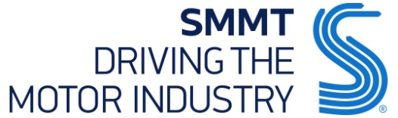

SMMT NEWS RELEASE
Thursday 3 March 2016 |  | FOR RELEASE: IMMEDIATE
Hi-res images available via Dropbox:
https://www.dropbox.com/sh/9x8c0og5sxzbgvf/AACs3y1mmveb6uavCX8XYiLZa?dl=0
Remaining in Europe best for our business, SMMT members reveal in new survey
- 77% of members of SMMT – the voice of the UK motor industry – say remaining in Europe is best for their business, according to 2016 survey by independent pollster ComRes.
- Overwhelming support for EU membership across the board, with 88% of large SMMT member companies and 73% of SME members in favour of remaining.
- Majority of firms say Brexit would have a negative impact on their business.
- Industry leaders from across the sector back the UK in Europe at press event in London.
Thursday 3 March, 2016 Three quarters of SMMT members say remaining in Europe is best for their business, according to the results of a new independent survey. The Society of Motor Manufacturers and Traders, which represents the breadth of UK automotive businesses, from car and CV makers to parts suppliers and aftermarket companies, will set out its members’ position on EU membership at a press conference in London today. The sector supports 800,000 jobs across the UK and contributes £15.5 billion to the UK economy.

77% of SMMT members surveyed said that if a referendum were held tomorrow, a ‘remain’ outcome would be best for their business, according to ComRes, who were commissioned to carry out the independent poll. It’s a sentiment shared by 88% of large automotive companies¹ who are SMMT members and 73% of SME members, with small and medium-sized businesses making up around three quarters of respondents (72%). Only a minority (9%) say leaving would be best, less than the proportion who are uncertain (14% don’t know). Notably, no large companies surveyed said an exit would be in their business’ best interests.

SMMT commissioned the poll, carried out over a five week period in January and February 2016, to get an up-to-date understanding of the views of its members about the importance of the EU so that this vital sector for the UK economy and jobs can speak with authority in the debate.

Delving into the reasons why the EU is important to them, SMMT members are most likely to say that access to EU automotive markets has a positive impact on their business (66%). This is followed by a majority saying that access to a skilled workforce (55%) and the ability to influence industry standards and regulations (52%) also have a positive impact on their business. When asked to provide open-ended feedback, some of the key reasons given for staying in the EU included the importance of economic and market stability, securing the UK’s global competitiveness, and access to the single market’s free trade opportunities.²

Looking ahead to the threat of a potential Brexit, 59% of SMMT members say it would have a negative impact on their business in the medium- to long-term, with a further one in five uncertain about the nature and extent of that impact (18% don’t know). When those foreseeing a negative impact were asked why, fears included becoming uncompetitive and losing business to EU rivals, while the risk of future investment being diverted to the continent also featured highly.

Mike Hawes, SMMT Chief Executive, said, “The message from UK Automotive is clear – being in Europe is vital for the future of this industry and to secure jobs, investment and growth. UK Automotive is thriving, with record car exports, new registrations and the highest manufacturing levels for a decade. Our industry supports 800,000 jobs across the UK and contributes more than £15 billion to the UK economy – our members have clearly stated that pulling out of Europe could jeopardise this.”

At a press conference today in London, senior figures from a wide range of automotive companies reinforced this message.
Dr Ian Robertson, Member of the Board of Management, BMW AG, said, “As a major employer, exporter and investor, the BMW Group is committed to the UK which is home to two of our brands, MINI and Rolls-Royce Motor Cars. Our experience shows that the free movement of components, finished products and skilled workers within the EU is extremely beneficial to British-based business. We firmly believe Britain would be better off if it remained an active and influential member of the EU, shaping European regulations which will continue to impact the UK whatever the decision in June.”
Nigel Stein, Chief Executive, GKN PLC, said, “As a leading UK listed Tier 1 supplier in the automotive industry, we serve the global car manufacturers invested in Europe. As such we see a real benefit in remaining in the EU. A vote to leave will not mean manufacturing investment disappears overnight, but over time a UK outside the EU will be disadvantaged and will lose the investment it needs to maintain our industries.”
Dr Graham Cooley, Chief Executive, ITM Power PLC, an AIM listed SME specialising in energy storage and clean fuel, said, “The UK’s membership of the EU is fundamentally important for ITM Power; most of the hydrogen refuelling infrastructure projects in the UK are funded from Brussels and our largest export market is the EU. Developing policy to achieve a low-carbon energy and transport system lies at the heart of EU thinking; this is a pre-requisite for achieving large markets and strong supply chains for low-carbon technologies.”

Gamil Magal, Group Chief Executive, Magal Engineering Limited, a medium-sized Tier 1 components supplier, said, “Full unhindered access to the European single market is essential for Magal Engineering’s UK operations. Our companies are based throughout the EU and the free movement of labour and materials across the continent is an essential part of our day-to-day operations and growth.”
Tony Walker, Deputy Managing Director, Toyota Motor Manufacturing UK, said, “Our UK operations are fully integrated within our European business – exporting nearly 90 percent of all UK built vehicles. We are very satisfied with the performance our UK operations and are committed to our employees and investments. We also recognise that the UK’s future relationship with the European Union is a matter for the British people to decide. After considered review, we believe that continued membership of the European Union is best for our business and for our competitiveness in the longer term.”
Rory Harvey, Managing Director and Chairman of Vauxhall, said, “The UK is the fourth largest global market for Vauxhall’s parent company GM and the largest EU market. We are part of a fully integrated European company where we benefit from the free movement of goods and people, and we believe not to be part of the EU would be undesirable for our business and the sector as a whole.”

This is the second time SMMT members have been canvassed on this critical issue – and the second time the overwhelming majority have stated that staying in Europe is best for their business. Reform remains important: When asked to select the three reforms that would be most beneficial to their business, the top options included were better regulation and reduction of red tape, and a greater emphasis on free trade and access to global markets – in line with the EU reforms now secured by UK government.

Tom Mludzinski, Director of Political Polling, ComRes, said, “This survey of SMMT members shows that the majority of these automotive industry companies see the European Union as having a positive impact on their business. It follows that a strong majority of members believe a Remain outcome would be the best result for their business.

Notes to Editors

¹ Large organisations are defined as those with 250+ employees.

Q If a referendum on the UK’s membership of the EU were held tomorrow, which result would be best for your business?

SMEs Large companies Total
Remain in the EU 73% 88% 77%
Leave the EU 12% 0% 9%
Don’t know 14% 12% 14%

Q What is the current impact of UK membership of the EU on your business?

SMEs Large companies Total
Positive 65% 84% 71%
No impact 21% 7% 17%
Negative 10% 3% 8%
Don’t know 5% 5% 5%

Q What is the impact of the UK’s membership of the EU on your business in each of the following areas?
(Showing % of top 3 most positive responses overall)
SMEs Large companies Total
Access to EU automotive markets 62% 76% 66%
Access to a skilled workforce 49% 71% 55%
Ability to influence industry standards and regulations 44% 74% 52%

Q Which of the following potential reforms, if any, would be most beneficial for your business? Please select up to three.
(Showing top 3 responses)
SMEs Large companies Total
Better regulation and reduction of red tape 60% 59% 60%
Better consistency and application of EU rules by all member states 44% 53% 47%
Greater emphasis on free trade and global market access 36% 45% 38%

Q If the UK left the EU, what would be the impact on your business in the medium to long-term (next 6-10 years)?

SMEs Large companies Total
Negative 51% 78% 59%
No impact 15% 10% 14%
Don’t know 21% 10% 18%
Positive 13% 2% 10%

² SMMT members’ verbatim views on...

Why EU membership matters
- “We trade extensively with the EU, any barrier to this would be bad for my business”
- “The prospects for jobs, exports and investments are enhanced in the single market…We are better together”
- “I believe leaving would weaken our position for international trade negotiations and isolate us from winning contracts abroad”
- “UK access to the EU is one significant reason for our location in the UK. As an engineering services company, unrestricted recruitment of skilled EU labour is an important strength. I do not believe this would continue if the UK leaves”

Brexit fears: Risks and uncertainties
- “…Leaving [the EU] will only put trade barriers in place, making growth harder and providing opportunities for EU-based competitors”
- “We would not be eligible for EU research grants and collaborative projects. Our competitors would be”
- “I think trading would become more difficult and economic and legislative barriers may well be put in place to isolate the UK as an outsider from the EU ‘club’ of economic union. Access to a willing and able workforce of economically mobile staff would also probably become harder”
- “Global OEMs will not invest in new models, while the UK’s involvement in a European supply chain will become harder”

ComRes interviewed 204 members of the Society of Motor Manufacturers and Traders (SMMT)* online between 14 January and 17 February 2016. ComRes is a member of the British Polling Council and abides by its rules. Data is available at www.comres.co.uk

*Survey respondents make up 43% of full SMMT members (475), and 91.5% of combined SMMT member annual turnover.

Images available to download
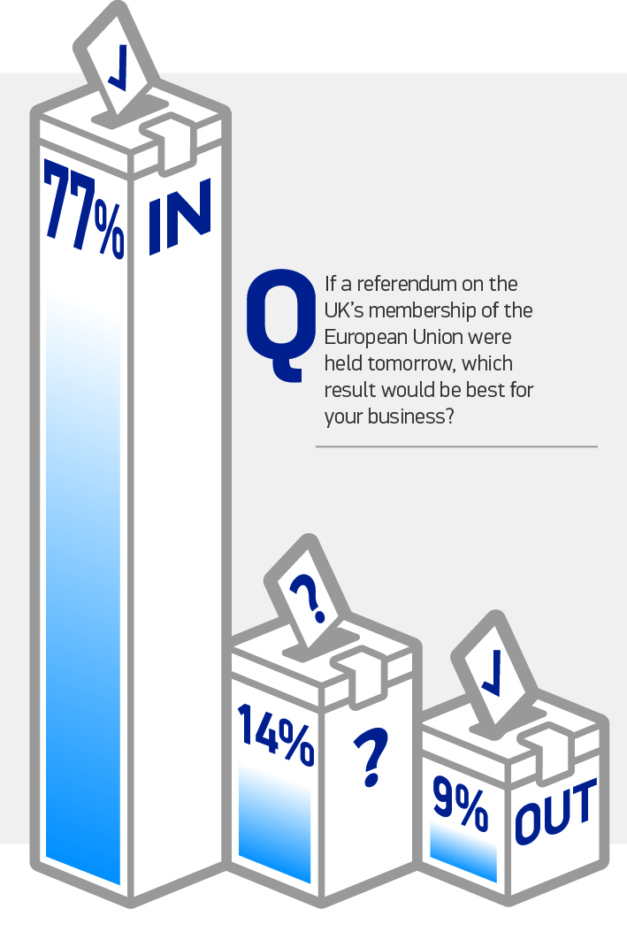
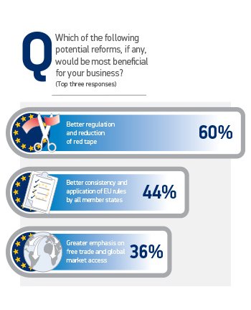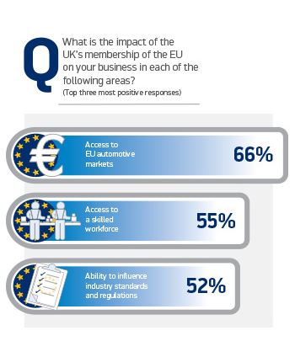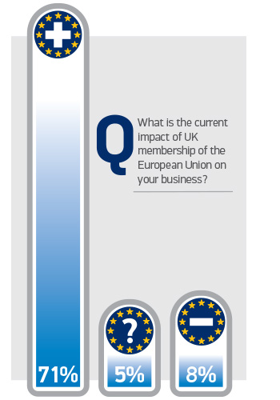

About SMMT and the UK automotive industry
The Society of Motor Manufacturers and Traders (SMMT) is one of the largest and most influential trade associations in the UK. It supports the interests of the UK automotive industry at home and abroad, promoting a united position to government, stakeholders and the media.

The automotive industry is a vital part of the UK economy accounting for more than £69.5 billion turnover and £15.5 billion value added. With some 160,000 people employed directly in manufacturing and in excess of 799,000 across the wider automotive industry, it accounts for 11.8% of total UK export of goods and invests £2.4 billion each year in automotive R&D. More than 30 manufacturers build in excess of 70 models of vehicle in the UK, supported by around 2,500 component providers and some of the world's most skilled engineers.

More detail on UK automotive available in SMMT's Motor Industry Facts 2015 publication at www.smmt.co.uk/facts15

Broadcasters: SMMT has an ISDN studio and access to expert spokespeople, case studies and regional representatives.

Media contacts
Lucy Bielby | 020 7344 1610 | lbielby@smmt.co.uk
Francesca Fleming | 020 7344 9206 | ffleming@smmt.co.uk
Ben Foulds | 020 7344 9222 | bfoulds@smmt.co.uk

