SMMT USED CAR SALES

10 November 2020 (data for Q3 2020)

Hi-res charts available via Dropbox:

https://www.dropbox.com/sh/pchqorxv5kjzvw4/AACe0_-E-VYcs8jL2vaJu60Ka?dl=0

UK used car market bounces back 4.4% in third quarter as more than 2 million change hands

- UK used car transactions grow 4.4% in Q3 as showrooms re-open, with 2,168,599 vehicles changing hands.
- Growth recorded in each month of the quarter, with September plate-change driving highest increase of 6.3%.
- Demand lifts across all fuel types, with biggest percentage growth enjoyed by electric vehicles after disappointing second quarter.
- Year to date transactions fall -17.5%, with some one million fewer transactions than the first nine months of 2020.

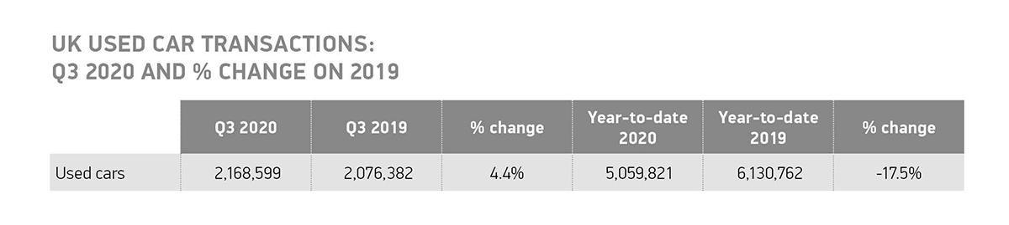

10 November, 2020 The UK’s used car market increased by 4.4% in Q3 after two consecutive quarters of decline, according to the latest figures published today by the Society of Motor Manufacturers and Traders (SMMT). During the busiest quarter since the end of 2016, some 2,168,599 transactions took place between July and September, 92,217 more than the same period in 2019, with September recording the largest growth, up 6.3%.

Despite the growth, spurred by the re-opening of showrooms and easing of lockdown measures across the country, the UK’s used car market is still down with 1,070,941 fewer transactions over the first nine months representing a decline of -17.5% overall.

With England entering a new lockdown and the introduction of tougher restrictions and ‘firebreaks’ across the devolved nations, sales in the fourth quarter are expected to be heavily affected. The swift re-opening of used car outlets – which are generally spacious premises with outdoor areas and which can accommodate social distancing far more easily than other retail environments – would go a long way to help prevent further subdued activity in the market, enabling the latest, lowest emitting vehicles to filter through to second owners.

Demand for pre-owned battery electric vehicles (BEVs), which saw a decline of -29.7% in the Q2 – albeit a lesser one than the market average of -48.9% – recovered during Q3, growing by 34.4% and 4.4% in the year to date. At the same time, sales of plug-in hybrids increased by 35.7%, with 10,040 changing hands. Petrol and diesel cars both saw an increase in sales of 4.5% and 2.6% respectively, accounting for 97.42% of all used transactions during the quarter.

Superminis, despite only seeing a modest 2.0% increase during the third quarter, remained the most popular segment with 698,587 purchases, accounting for 32.0% of transactions. The lower medium was the next best seller with 27.0% of the total market share. Meanwhile, the dual-purpose segment showed the largest percentage growth (16.6%) with 13.0% market share as more of these popular vehicles entered the used market.

In other trends, black held its position as the number one colour among used car buyers, ahead of silver/aluminium and blue, with 56.5% of used cars sold in the third quarter clad in the top three colours. Bronze saw the biggest growth, up 16.1%, albeit representing just 5,958 of the 2.16 million cars sold in Q3 while cream/ivory decreased most significantly by -10.8%.

Mike Hawes, SMMT Chief Executive, said, “With England entering a fresh lockdown, and tighter Covid restrictions in place across the rest of the UK, the car is playing an even more important role in keeping society moving as public transport becomes less attractive for many. It is encouraging to see used car sales returned to growth but, as the pandemic continues and outlets in many areas are being made to close again, the short-term outlook is less positive. Given these premises are often proven to be Covid-secure, we need them to re-open quickly to protect vital jobs and ensure no further delay to the fleet renewal necessary to deliver environmental improvements.”

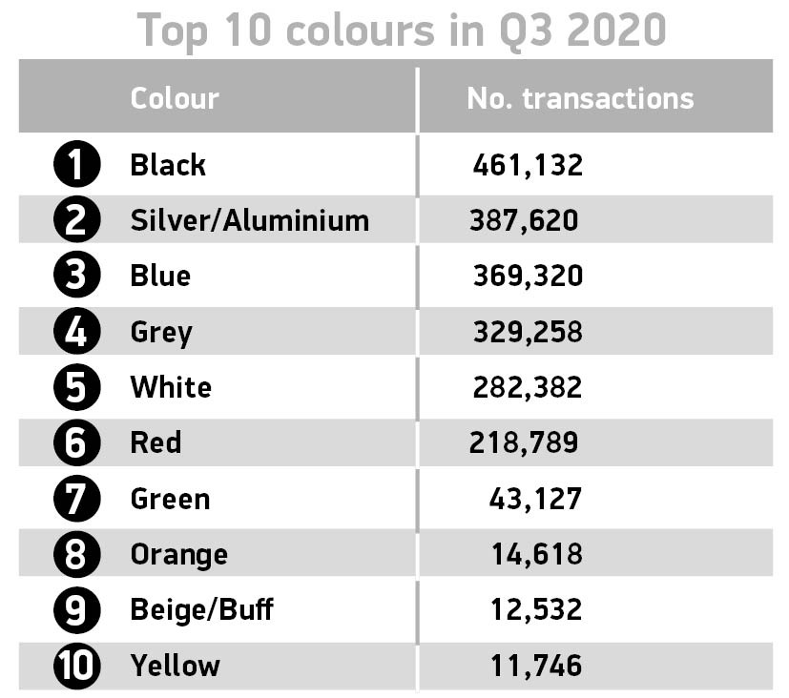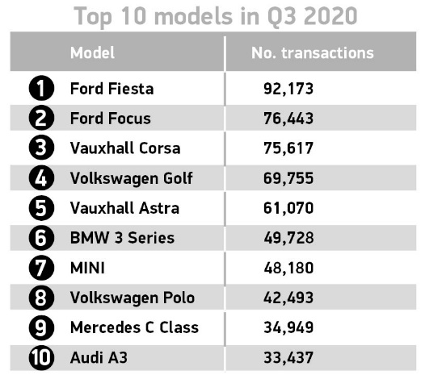

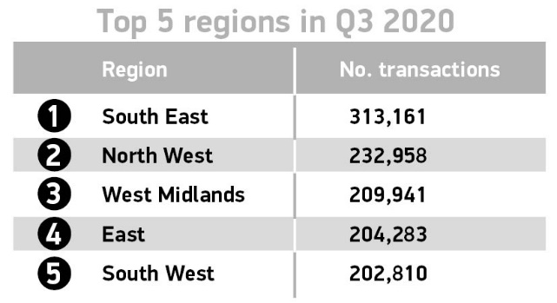

Notes to editors

About SMMT and the UK automotive industry

The Society of Motor Manufacturers and Traders (SMMT) is one of the largest and most influential trade associations in the UK. It supports the interests of the UK automotive industry at home and abroad, promoting a united position to government, stakeholders and the media.

The automotive industry is a vital part of the UK economy accounting for £78.9 billion turnover and £15.3 billion value added. With some 180,000 people employed directly in manufacturing and 864,000 across the wider automotive industry, it accounts for 13% of total UK export of goods and invests more than £3 billion each year in automotive R&D. More than 30 manufacturers build some 70 models of vehicle in the UK supported by 2,500 component providers and some of the world's most skilled engineers.

More detail on UK automotive available in SMMT's Motor Industry Facts 2020 publication at smmt.co.uk/facts20

Broadcasters: SMMT has an ISDN studio and access to expert spokespeople, case studies and regional representatives.

Media contacts:

Paul Mauerhoff 020 7344 9233 pmauerhoff@smmt.co.uk
James Boley 020 7344 9222 jboley@smmt.co.uk
Aleona Krechetova 020 7344 9215 akrechetova@smmt.co.uk
Daniel Zealander 020 7344 1667 dzealander@smmt.co.uk
Emma Butcher 020 7344 9263 ebutcher@smmt.co.uk

