UK COMMERCIAL VEHICLE MANUFACTURING

24 March 2016 (data for February 2016)
Steady February for CV manufacturing as exports drive demand
- Modest 1.5% growth for British commercial vehicle manufacturing in February.
- Production for export up by a fifth, outweighing a 13.2% fall in output for the domestic market.
- CV manufacturing up 10.5% in the first two months of 2016 compared with the same period last year.
24 March, 2016 British commercial vehicle manufacturing made moderate gains in February with overall output up 1.5% over the same month last year, according to new figures from the Society of Motor Manufacturers and Traders (SMMT). For the second month in a row, a sharp lift in overseas demand, up 19.9%, offset a 13.2% fall in production for UK buyers. Following a strong January, production for the year so far is up 10.5% over the equivalent 2015 period.
Mike Hawes, SMMT Chief Executive, said, “February’s positive CV output, while more subdued than in January, continued to reflect buoyant demand for British-built vans, trucks, buses and coaches. Once again, the ongoing recovery in European markets was the driving factor, with output for export growing for the seventh consecutive month, and up by more than a third for the year to date.”
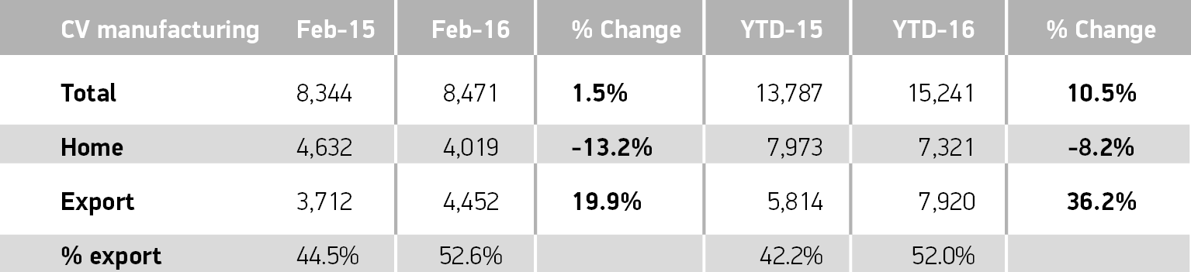
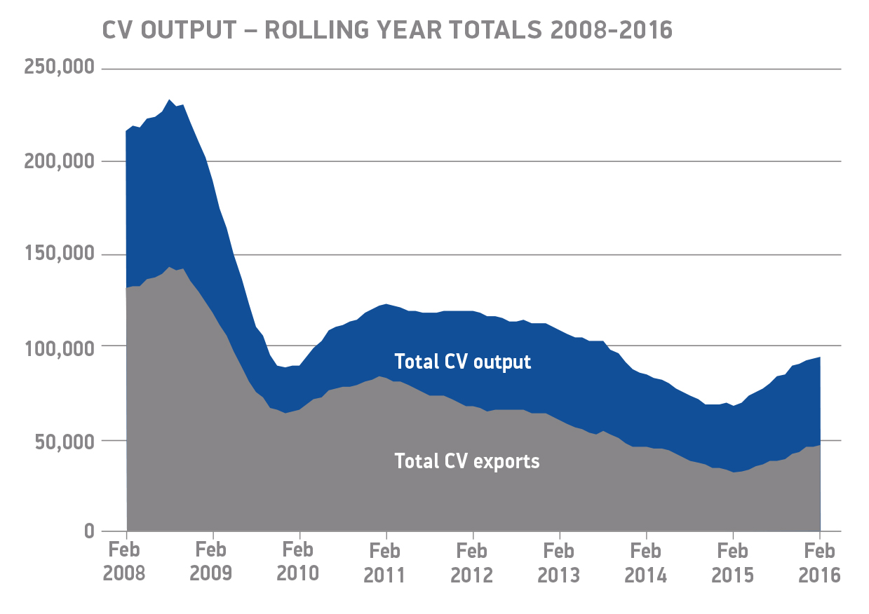
Notes to editors

About SMMT and the UK automotive industry

The Society of Motor Manufacturers and Traders (SMMT) is one of the largest and most influential trade associations in the UK. It supports the interests of the UK automotive industry at home and abroad, promoting a united position to government, stakeholders and the media.

The automotive industry is a vital part of the UK economy accounting for more than £69.5 billion turnover and £15.5 billion value added. With some 160,000 people employed directly in manufacturing and in excess of 799,000 across the wider automotive industry, it accounts for 11.8% of total UK export of goods and invests £2.4 billion each year in automotive R&D. More than 30 manufacturers build in excess of 70 models of vehicle in the UK supported by around 2,500 component providers and some of the world’s most skilled engineers.

More detail on UK automotive available in SMMT’s Motor Industry Facts 2015 publication at www.smmt.co.uk/facts15.

Broadcasters: SMMT has an ISDN studio and access to expert spokespeople, case studies and regional representatives.
Media contacts
Ben Foulds | 020 7344 9222 | bfoulds@smmt.co.uk
Emma Butcher | 020 7344 9263 | ebutcher@smmt.co.uk
Francesca Fleming | 020 7344 9206 | ffleming@smmt.co.uk

