UK COMMERCIAL VEHICLE MANUFACTURING

28 July 2016 (data for June and H1 2016)
UK CV production falls in June as market stabilises
- UK commercial vehicle production falls -21.7% in June as demand rebalances after 2015 spike.
- 47,621 CVs produced so far in 2016 – a slight decrease of -2.2%.
- Exports up 2.7% in the year-to-date, with more than half of UK-built CVs sold overseas.
Thursday 28 July, 2016 UK commercial vehicle manufacturing saw a decline in June, according to figures published today by the Society of Motor Manufacturers and Traders (SMMT). 7,686 CVs were built in Britain last month, down -21.7% compared with the previous year as the market rebalanced following a particularly strong performance in June 2015.

Mike Hawes, SMMT Chief Executive, said, “Disruption to fleet renewal patterns triggered by type approval changes last year meant manufacturing output spiked by more than half in June 2015.¹ As a result, this year's June performance was always going to be negative so the drop is no surprise. The market remains at a high level, buoyed by continuing resurgence in key EU markets, with more than half of UK CV output sold overseas. Maintaining the competitive trading conditions currently afforded by EU membership, including free access to major international markets, will be critical to this sector’s future performance.”
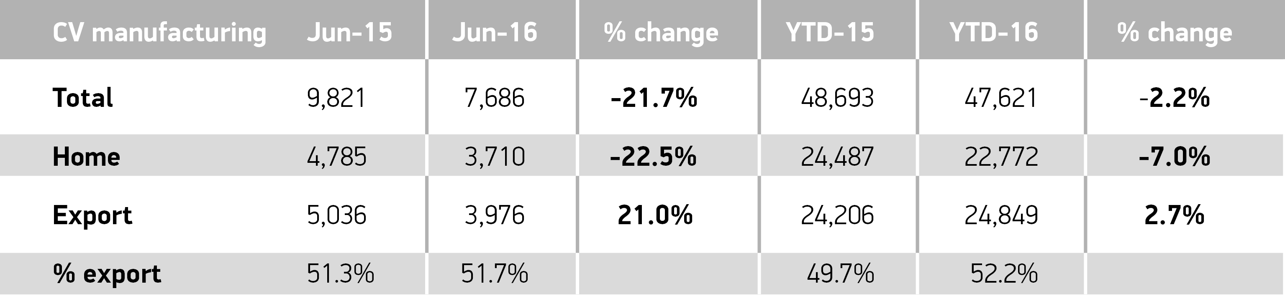

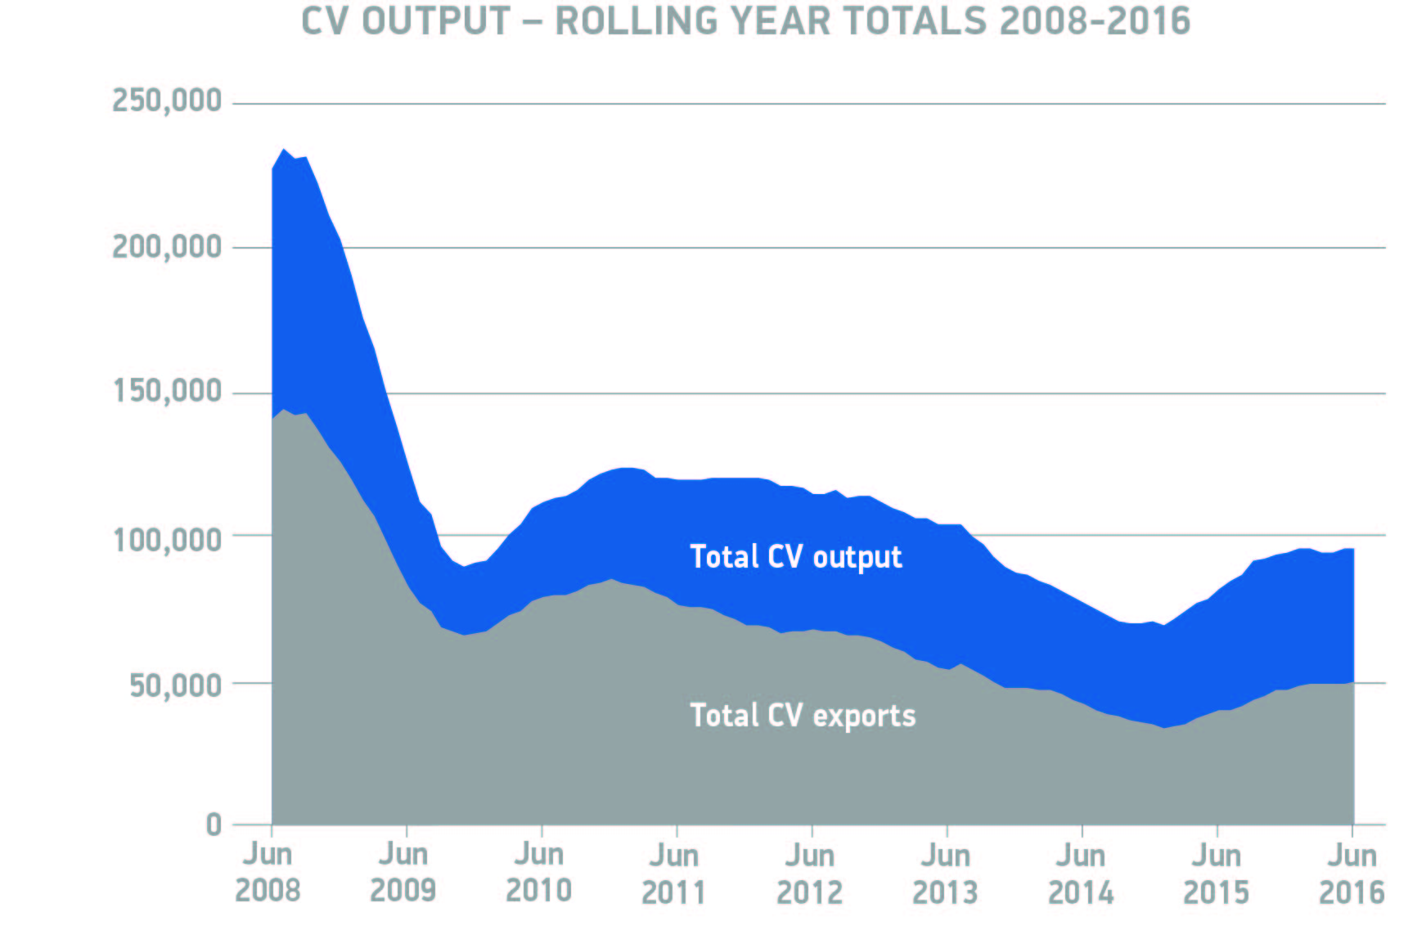
Notes to editors
1. Total UK CV manufacturing volumes grew from 6,348 units in June 2014 to 9,821 in June 2015, a rise of 54.7%: SMMT data
About SMMT and the UK automotive industry
The Society of Motor Manufacturers and Traders (SMMT) is one of the largest and most influential trade associations in the UK. It supports the interests of the UK automotive industry at home and abroad, promoting a united position to government, stakeholders and the media.
The automotive industry is a vital part of the UK economy accounting for more than £71.6 billion turnover and £18.9 billion value added. With some 169,000 people employed directly in manufacturing and 814,000 across the wider automotive industry, it accounts for 12.0% of total UK export of goods and invests £2.5 billion each year in automotive R&D. More than 30 manufacturers build in excess of 70 models of vehicle in the UK supported by more than 2,000 component providers and some of the world's most skilled engineers.
More detail on UK automotive available in SMMT's Motor Industry Facts 2016 publication at www.smmt.co.uk/facts16.
Broadcasters: SMMT has an ISDN studio and access to expert spokespeople, case studies and regional representatives.
Media contacts

Keely Scanlan | 020 7344 9222 | kscanlan@smmt.co.uk
Lucy Bielby | 020 7344 1610 | lbielby@smmt.co.uk
Eleanor Fricker | 020 7344 1667 | efricker@smmt.co.uk
Emma Butcher | 020 7344 9263 | ebutcher@smmt.co.uk

