UK CAR MANUFACTURING (data for April 2016)
Strictly embargoed to 00:01 on 25 May 2016
Hi-res images available here:

https://www.dropbox.com/sh/8ai421xwcl6dtts/AAB6cdlQ_9Tvnlgahs2Km2Qja?dl=0
Export growth sees healthy rise for UK car production in April
- UK car production makes further positive gains in April, up 16.4% with 149,334 units built.
- Strong growth in manufacturing for export, with volumes up 23.7% in the month.
- 588,024 cars built in 2016 so far – a 10.8% rise over the same period last year.
Wednesday 25 May, 2016 UK car manufacturing continued to make significant gains in April, according to figures released today by the Society of Motor Manufacturers and Traders (SMMT). Almost 150,000 cars were built in the month, a 16.4% increase on April 2015, and marking the ninth consecutive month of growth.

Increasing overseas demand for British-built cars was again the driving force behind the growth: production for export jumped 23.7% in April, counterbalancing a 7.8% decline in cars made for the domestic market.

April’s figures bolster an already positive 2016 for UK car output, with 588,024 cars built in the first four months of the year – up 10.8% on the equivalent period in 2015.

Mike Hawes, SMMT Chief Executive, said, “Britain’s car manufacturing sector continues to thrive with a steady domestic market and surging demand from overseas, including our biggest export destination, Europe. This growth represents a significant endorsement of the strength and quality of the UK automotive industry.”

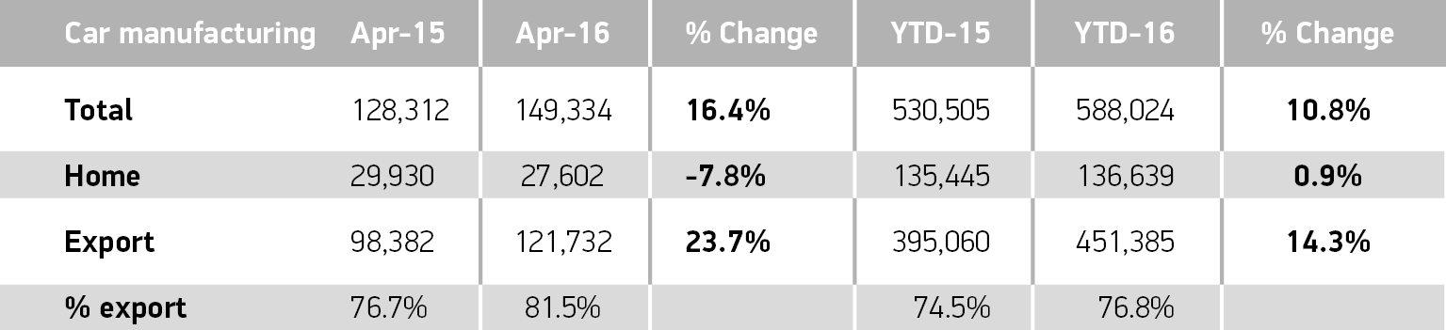
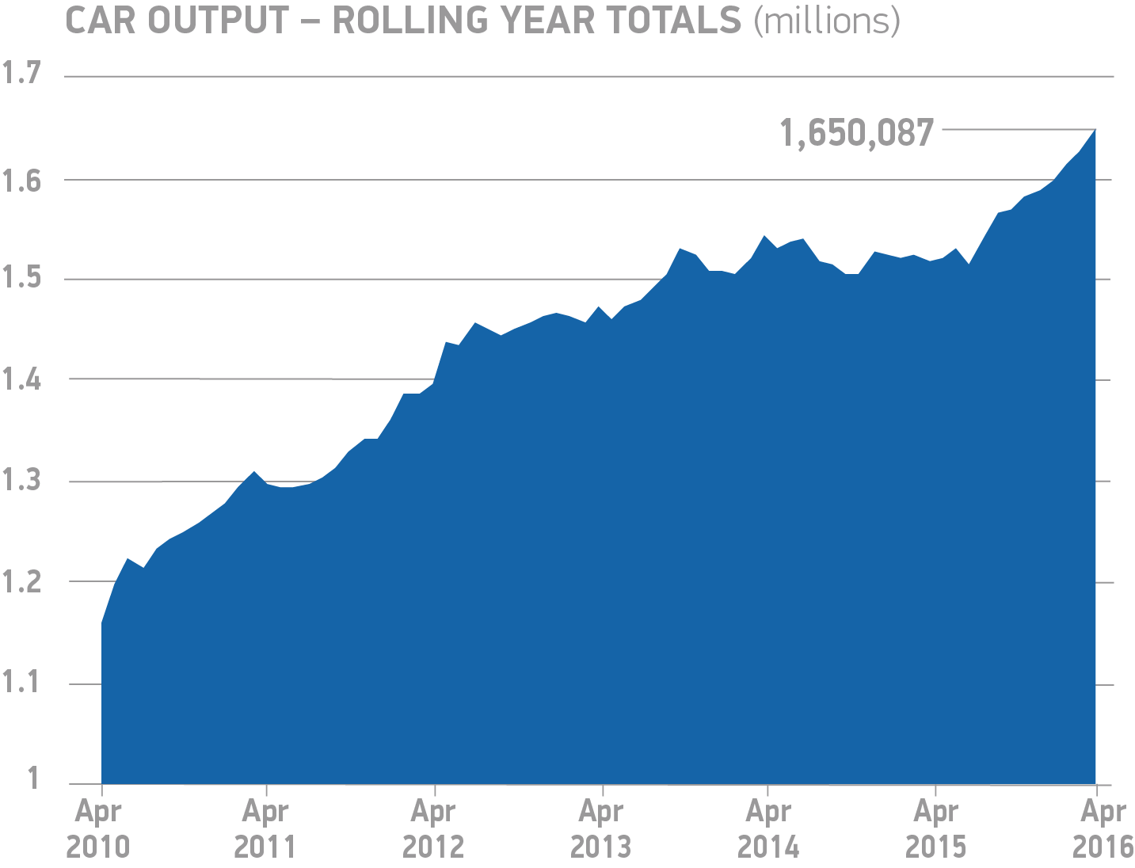
About SMMT and the UK automotive industry

The Society of Motor Manufacturers and Traders (SMMT) is one of the largest and most influential trade associations in the UK. It supports the interests of the UK automotive industry at home and abroad, promoting a united position to government, stakeholders and the media.

The automotive industry is a vital part of the UK economy accounting for more than £69.5 billion turnover and £15.5 billion value added. With some 160,000 people employed directly in manufacturing and in excess of 799,000 across the wider automotive industry, it accounts for 11.8% of total UK export of goods and invests £2.4 billion each year in automotive R&D. More than 30 manufacturers build in excess of 70 models of vehicle in the UK supported by around 2,500 component providers and some of the world's most skilled engineers.

More detail on UK automotive available in SMMT's Motor Industry Facts 2015 publication at www.smmt.co.uk/facts15.

Broadcasters: SMMT has an ISDN studio and access to expert spokespeople, case studies and regional representatives.
Media contacts

Ben Foulds  Francesca Fleming  Emma Butcher  Lucy Bielby | 020 7344 9222  020 7344 9206  020 7344 9263  020 7344 1610 | bfoulds@smmt.co.uk  ffleming@smmt.co.uk  ebutcher@smmt.co.uk  lbielby@smmt.co.uk

