UK CAR MANUFACTURING (data for March and Q1 2016)
Hi-res images available here:

https://www.dropbox.com/sh/6q7v5lx2cosb3wy/AADBH21Orb3IBB197_tRlZ-ta?dl=0
One every 16 seconds: British car manufacturing grows again in March, marking best Q1 since 2004
- UK car production grows 9.8% in March, with 159,074 cars built – one every 16 seconds.
- 443,581 cars made in the first quarter, rising 10.3% as productivity reaches record levels.
- Q1 demand up at home and abroad, with domestic output up 8% and exports up 11.1%.
28 April, 2016 British car manufacturing continued its strong growth in March with output increasing 9.8% to 159,074 units, according to figures released today by the Society of Motor Manufacturers and Traders (SMMT).

Overseas demand showed the biggest gains, up 14.3% in the month, while production for the home market was broadly stable, falling slightly by -1.4%. It was a trend reflected in first quarter figures, with exports for the first three months growing 11.1% to 329,653 units, while domestic output also rose by 8%, buoyed by stronger growth in January and February, to take overall manufacturing volumes to 443,581, an increase of 10.3%.

The news comes as the latest productivity figures released for 2015 show that each employee in automotive manufacturing generated on average £79,700 per car produced, up 1.3% on 2014 – the highest on record, and around twice the UK national average.¹

Mike Hawes, SMMT Chief Executive, said, “UK car plants were at their busiest for 12 years in March,² with a vehicle rolling off production lines every 16 seconds thanks to heightened international demand for British-built cars. Much will depend on economic and political conditions in key markets but, with several brand new global models starting production here in the first quarter alone, the prospects for future growth look bright.”
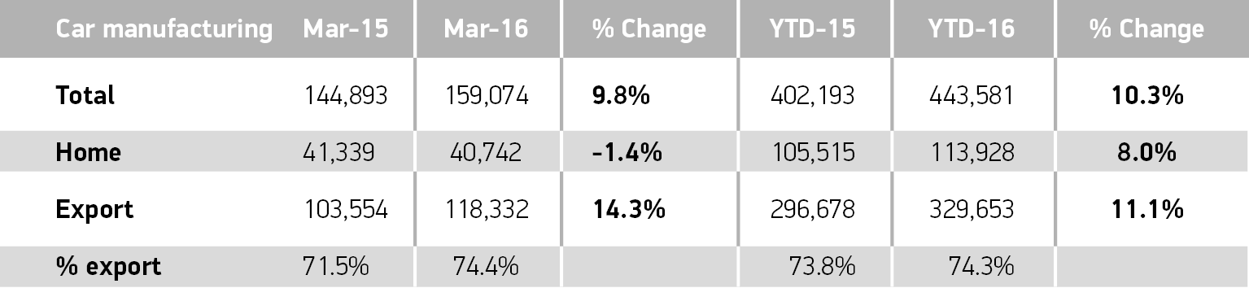
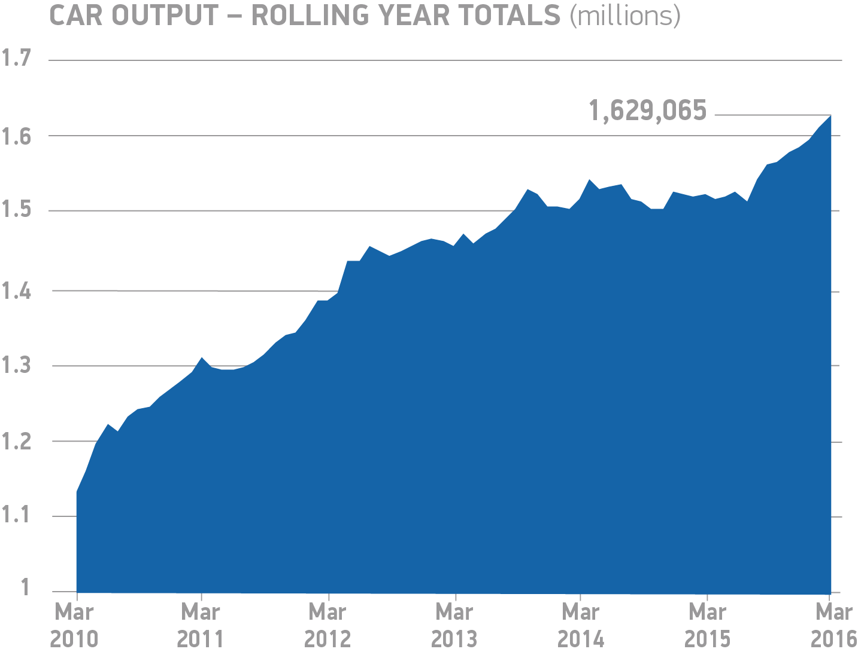
Notes to editors

1 GDP value added per job at current prices calculated using ONS and SMMT data, 2015

2 163,009 cars produced in March 2004; 445,424 in Q1 2004 - SMMT data

3 One car was produced in the UK every 16.7 seconds in March 2016 – SMMT data

About SMMT and the UK automotive industry

The Society of Motor Manufacturers and Traders (SMMT) is one of the largest and most influential trade associations in the UK. It supports the interests of the UK automotive industry at home and abroad, promoting a united position to government, stakeholders and the media.

The automotive industry is a vital part of the UK economy accounting for more than £69.5 billion turnover and £15.5 billion value added. With some 160,000 people employed directly in manufacturing and in excess of 799,000 across the wider automotive industry, it accounts for 11.8% of total UK export of goods and invests £2.4 billion each year in automotive R&D. More than 30 manufacturers build in excess of 70 models of vehicle in the UK supported by around 2,500 component providers and some of the world's most skilled engineers.

More detail on UK automotive available in SMMT's Motor Industry Facts 2015 publication at www.smmt.co.uk/facts15.

Broadcasters: SMMT has an ISDN studio and access to expert spokespeople, case studies and regional representatives.
Media contacts

Ben Foulds  Francesca Fleming  Emma Butcher  Lucy Bielby | 020 7344 9222  020 7344 9206  020 7344 9263  020 7344 1610 | bfoulds@smmt.co.uk  ffleming@smmt.co.uk  ebutcher@smmt.co.uk  lbielby@smmt.co.uk

