UK CAR MANUFACTURING (data for May 2016)

Thursday 30 June 2016
Hi-res images available here:

https://www.dropbox.com/sh/3ghc59wysza8w8p/AACRUiNht04GgafnMwZoQYoza?dl=0
UK car production up a quarter in May but business certainty vital for future
- UK car manufacturing makes big gains in May, with 150,802 vehicles produced – up 26.4%.
- Strong growth in production for both home and export markets, up 22.7% and 27.3% respectively.
- Industry body warns urgent action needed to provide certainty and stability for future growth.
Thursday 30 June, 2016 UK car manufacturing output rose by a quarter in May, according to new figures published today by the Society of Motor Manufacturers and Traders. 150,802 cars were built in the month, a 26.4% jump compared with May last year.
Production for domestic and export markets saw respective rises of 22.7% and 27.3%, as demand for UK-built cars around the world continues to grow.
May’s increase was the biggest since August 2015, which saw a 40.6% increase in output. Production in 2016 so far is now 13.6% ahead of the same period last year. Output was predicted to be high for 2016 due to record investment levels and the launch of several new models across the UK.
Mike Hawes, SMMT Chief Executive, said, “May’s performance is another strong month for UK car manufacturing, with demand for British-built vehicles up by over quarter. For this success to continue, we need government to maintain economic stability and help deliver the wider benefits – including free access to our biggest market – which have helped make the sector so globally competitive.”
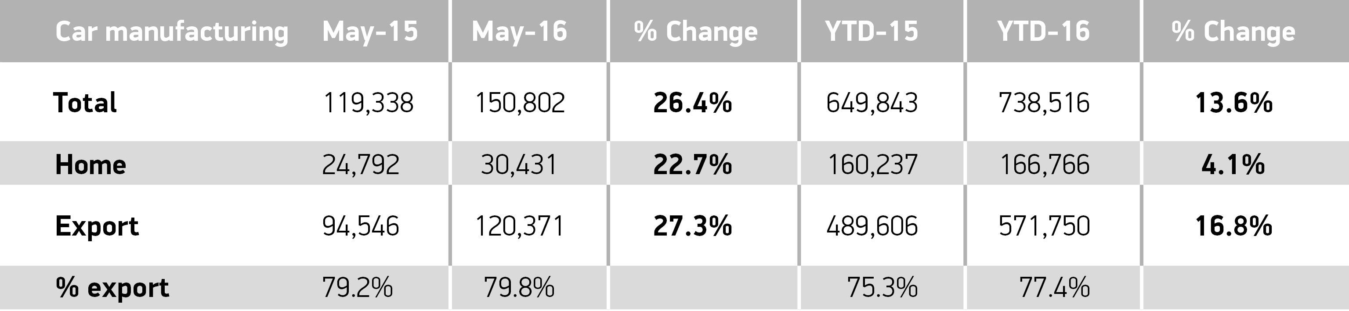
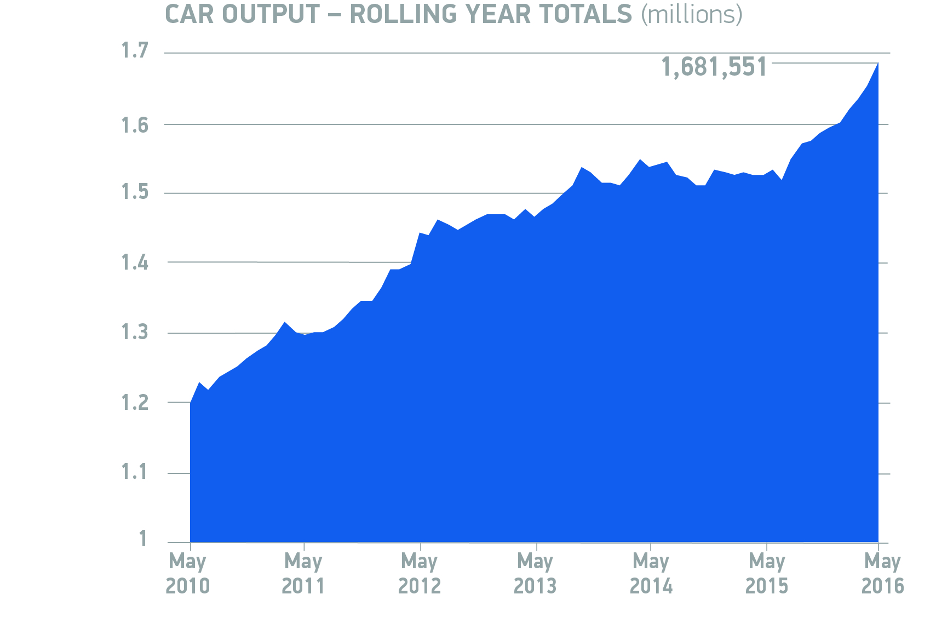
Notes to editors

About SMMT and the UK automotive industry
The Society of Motor Manufacturers and Traders (SMMT) is one of the largest and most influential trade associations in the UK. It supports the interests of the UK automotive industry at home and abroad, promoting a united position to government, stakeholders and the media.
The automotive industry is a vital part of the UK economy accounting for more than £71.6 billion turnover and £18.9 billion value added. With some 169,000 people employed directly in manufacturing and 814,000 across the wider automotive industry, it accounts for12.0% of total UK export of goods and invests £2.5 billion each year in automotive R&D. More than 30 manufacturers build in excess of 70 models of vehicle in the UK supported by more than 2,000 component providers and some of the world's most skilled engineers.
More detail on UK automotive available in SMMT's Motor Industry Facts 2016 publication at www.smmt.co.uk/facts16.
Broadcasters: SMMT has an ISDN studio and access to expert spokespeople, case studies and regional representatives.
Media contacts

Ben Foulds  Emma Butcher  Lucy Bielby | 020 7344 9222  020 7344 9263  020 7344 1610 | bfoulds@smmt.co.uk  ebutcher@smmt.co.uk  lbielby@smmt.co.uk

